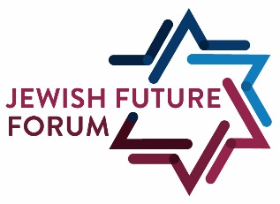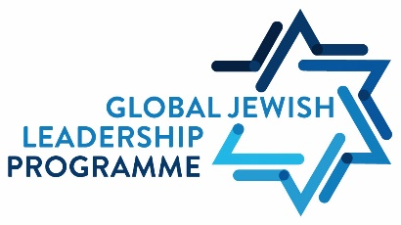

Call for Applications

Global Jewish Leadership Programme

Scholarship Programme for Non-EU National Jewish Students
The new Global Jewish Leadership Programme offered by the Ernst Ludwig Ehrlich Studienwerk (ELES) and made possible by direct funding from the German Federal Foreign Office is directed at non-EU national Jewish students who are pursuing a degree programme (BA and MA) at a German university.

By offering scholarships to Jewish leaders from non-EU countries, the Global Jewish Leadership Programme seeks to contribute to the strengthening of Jewish Change Agents amongst Jewish communities across the globe. We believe that self-confident, well networked and socially engaged Jewish students are prime candidates to support their communities and advance the interests of the Jewish people in Germany and in the wider world.

Students from outside the European Union will have the opportunity for intensive academic,
cultural, and religious exchange with other ELES scholarship holders as well as a network of
renowned European Jewish academics and public and cultural figures. By collaboratively working on interdisciplinary grant proposals, the students will strengthen and highlight their individual communities. Deepening and strengthening the bonds of global Jewish peoplehood and supporting future Jewish leaders are the core goals of the Global Jewish Leadership Programme.

What we offer – The Global Jewish Leadership Programme
The material and intellectual support of non-EU national Jewish students aims to make it possible for the scholarship recipients to pursue their degree at a German university while also helping them to become active and engaged in various areas of social life, civil society, and extra-curricular initiatives.

The GJLP scholarship recipients join the group of ELES scholarship holders and are included in the full ELES programme. They will take part in regional group meetings, seminars, and shared Shabbatot. All ELES events taking place as part of the regularly-scheduled intellectual support programme are also open to the GJLP scholarship recipients. Participation in at least one programme event per year is mandatory.

All scholarship holders receive regular individual advising from the Jewish Future Forum team. The scholarships are first awarded for a 12-month period. Extensions are possible. Scholarship holders are required to deliver biyearly status reports and to maintain open communication with the JFF team.

***Scholarship holders will have the opportunity to attend a German language course once their scholarship period begins ***

Financial support for BA and MA students and doctoral candidates per month
• €861 basic scholarship
• €100 supplementary support for health insurance
• €100 one-time initial help
• €300 travel allowance
• With the possibility additional financial support for families

As part of the GJLP scholarship holders are expected to pursue a research project, which will be supported with a micro-grant of up to €2000. Prospective applicants must submit a concrete proposal for a micro-grant with their application. All GJLP scholarship holders will advise and decide on the content and implementation of the micro-grant projects. All scholarship recipients will cooperate and advise for each project. The micro-grant projects should have an interdisciplinary character. The JFF team will act in an advisory and support role to assist the scholarship holders in implementing the micro-grant projects.

Application Process
The scholarship programme is designed for non-EU nationals. Unfortunately, individuals who are dual citizens with an EU-citizenship and a non-EU citizenship are ineligible. Applicants need to belong to a Jewish community in their country of origin; ELES and the JFF accept as Jewish anyone who has at least one Jewish parent or has gone through a recognized giur process. Applicants cannot have resided in the Federal Republic of Germany of a period of more than 3 months prior to application, with the exception of an already commenced degree programme. The application deadline for the first round is 31st July, 2021.

Application Requirements
• very good academic performance
• societal/civil society engagement
• engagement in the Jewish community
• Place at university/matriculation/acceptance to a German university or proof of application
• At least 2 remaining semesters before degree completion
• non-EU citizenship
• Basic German language skills (B2)

Application Materials (to be submitted in English through our online application portal)
• Motivation letter (max. 2 pages)
• Standard format CV (max. 2 pages)
• Micro-Grant project proposal (max. 1 page)
• University entrance qualification (Abitur, A-Levels, etc.)
• Enrolment certificate, acceptance letter, or proof of application to a university in Germany
• Copy of your passport
• Proof of your societal engagement
• Two academic assessments/letters of recommendation
• One non-academic letter of recommendation
• Further university or professional certificates (if applicable)
• Further performance certifications (if applicable)
• Only for doctoral candidates: a short exposé of your PhD research project

Contact: Rabbi Maximilian Feldhake: feldhake@eles-studienwerk.de;
Jewish Future Forum | ELES (eles-studienwerk.de)

The Ernst Ludwig Ehrlich Studienwerk
The Ernst Ludwig Ehrlich Studienwerk (ELES) is one of the thirteen scholarly funding bodies for gifted young academics supported by the Federal Ministry of Education and Research (BMBF). ELES supports especially gifted and needy Jewish students and doctoral candidates from all Jewish denominations in accordance with BMBF guidelines. Since its founding in 2009, ELES has stood for a pluralistic and confident Judaism and Jewish community conscious of its traditions and open to the world. Academic excellence and engagement for the Jewish community and society as a whole are united within ELES. With its targeted support for gifted Jewish students and doctoral candidates, ELES makes an important contribution to the education of a new Jewish intellectuality. For more information please visit our website: ELES (eles-studienwerk.de).

Leo Baeck Foundation
The declared purpose of the Leo Baeck Foundation, founded in Baeck’s honor on the 50th anniversary of his death, is to support the Jewish community in Europe by promoting Jewish religious congregations, particularly their efforts to pass on Jewish religious learning and tradition to coming generations. Another key focus of the Foundation is the exploration of fresh angles for constructive inter-faith dialogue. Leo Baeck Foundation (leo-baeck-foundation.org)
